**SPH3U: 1.2 Speed and Velocity**

1. **Recap**

|  |  |  |
| --- | --- | --- |
| distance | position | displacement |
|  |  |  |

1. **Average speed and velocity**

|  |  |
| --- | --- |
| Average speed: |  |

Your dog runs in a straight line for a distance of 43 m in 28 s. What is your dog’s average speed?

A baseball rolls along a flat parking lot in a straight line at a constant speed of 3.8 m/s. How far will the baseball roll in 15 s?

|  |  |
| --- | --- |
| Average velocity: |  |
| position-time graph |  |
| slope |  |

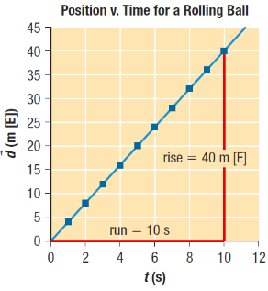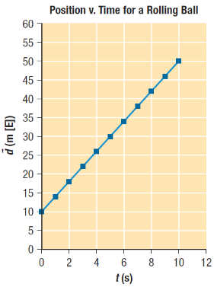

On a windy day, the position of a balloon changes as it is blown 82 m [N] away from a child in 15 s. What is the average velocity of the balloon?

A subway train travels at an average velocity of 22.3 km/h [W]. How long will it take for the subway train to undergo a displacement of 241 m [W]?

1. **Motion with uniform and non-uniform velocity**

|  |  |
| --- | --- |
| Uniform velocity: |  |
| Non-uniform velocity: |  |
| accelerated motion |  |

|  |  |  |
| --- | --- | --- |
| **Example** | **Uniform?** | **Why?** |
| A car travels down a straight highway at a steady 100 km/h. |  |  |
| A passenger on an amusement park ride travels in a circle at a constant speed of 1.2 m/s. |  |  |
| A parachutist jumps out of an aircraft. |  |  |

|  |  |  |
| --- | --- | --- |
| **Position-Time Graph** | **Type of Motion** | **Example** |
|  |  |  |
|  |  |  |
|  |  |  |
|  |  |  |
|  |  |  |

**Homework:** page 20: #1, 4-8